Say goodbye to the present and hello to the history of minecraft worlds! First, the latest worlds on minecraft. Katie’s “monster free” world in creative. It has a plaza, a mine, storage, a store, and a master bedroom. And we couldn’t miss living the Dream. It has a furnace and mine and steps! The most momentum full world ever!! A world of James’s (creative) he had blown up a waterfall and it came through beautifully. And then he made a vast hotel and house underwater! The worst survival was Katie’s “jungle” world. Monsters took over! But she began a new life there and it’s going well! I’ll give you a time line of minecraft “people”.
2011, Jan: minecraft words are wimpy for it only just got out.
2011, Feb & Mar: the nationwide worlds are getting better, although people are finding it hard to survive.
2012, June & July: True minecrafters are being made, like James M.

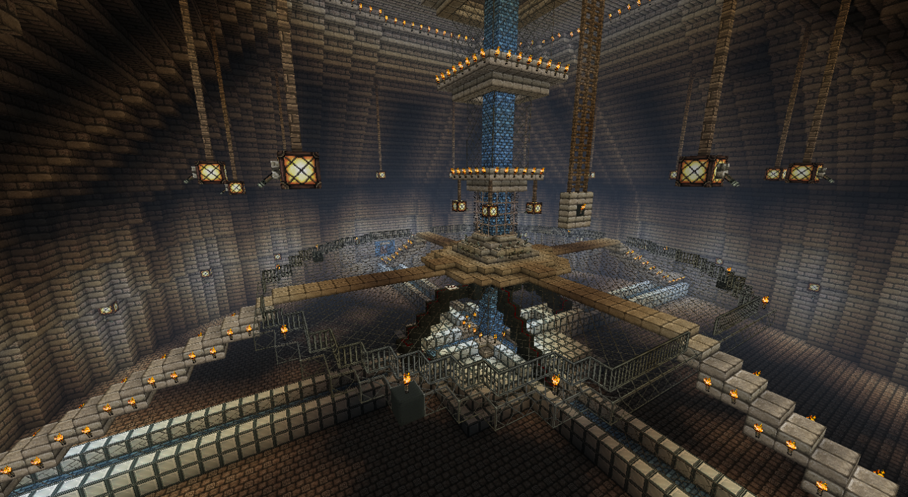
The TARDIS in construction. By thejamjar23.

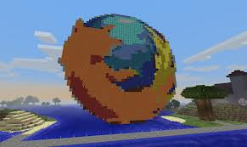 The huge Firefox symbol!
People have made strange minecraft worlds and more to come. I will introduce some more photos.
Beware…

Disneyland :) ha! 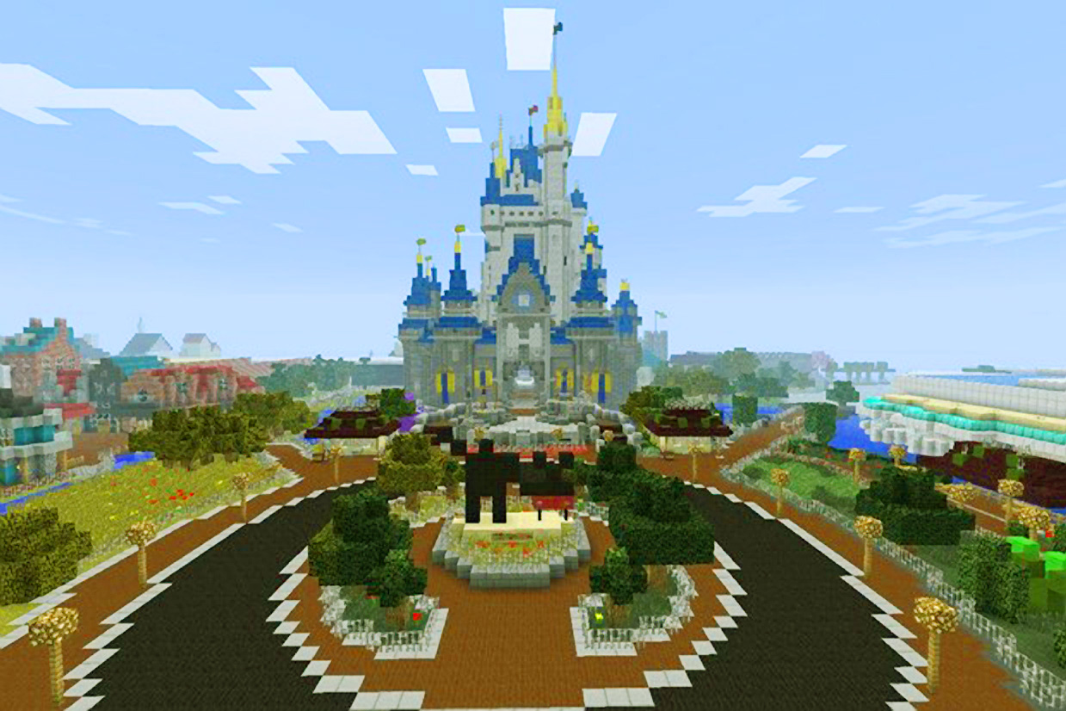
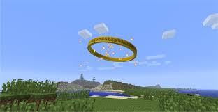 Lord of the rings
Ready for some more?
The next are seriously brain-popping!
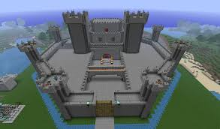 One seriously awesome castle!!
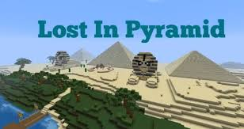 Egypt in minecraft!!!
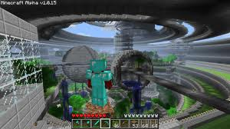 Look closely and you’ll find awesomeness…
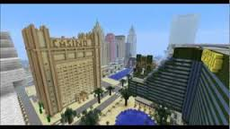 The Monte Carlo, Las Vegas.
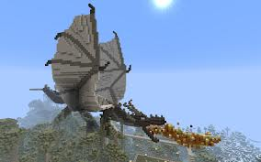 The fire-breathing dragon!!! Dun dun duh!!!
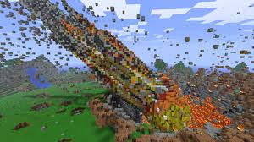 The impact of a crater or a comet, I can’t tell… can you?
Most of these have taken a long time to build. Just don’t get too addicted to minecraft! The crater… er…comet must have taken a zillion blocks. And a lot of views on a close up photo.
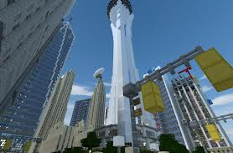 Stratosphere!!! Or Seattle point, I can’t tell…
If you want no more photos, skip the next page.
Otherwise, beware…
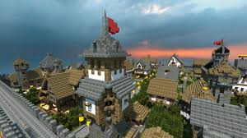 London in 1860…
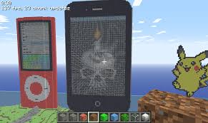 Play on your phone while playing on your phone!!!
Alright, enough photos. Minecraft can be played on the computer, phone, and Xbox. Huge spheres have been seen like UFOs across minecraft websites. There have been over 50 big and small spheres noted. Minecraft wallpaper is very popular nowadays, and is known to have Steve, monsters, or blocks on it. UTube’s an eggs guide to minecraft is very popular too. It’s great and a “have to” to know the newest minecraft stuff if you like minecraft. If you want see more photos and minecraft “stuff” you should go to Google images and type minecraft buildings, and for stuff go to ThinkGeek and type minecraft in their search bar. It is a little known fact that furnaces in minecraft need coal or wood to cook chicken, beef, and pork. Here are some more little known facts.
- Fences can dry out water in their “block” when you place them.
- One dye can be made promptly in survival, which is unusual: dandelion yellow. It’s made with yellow flowers which can be easily found.
- Stone pickaxes last a surprising length of time; but diamond pickaxes last forever.

Introducing the most little known fact of them all…
- Leather boots look stupid on you. Believe me, I’ve tried them on, they’re like mushy brown things stuck to your feet.

As in all, never try on leather boots. Or a leather helmet, chestplate, or leggings. You’ll be a laughing facility if anyone sees you on server.

Flash news
Abiding gravity
News flash! In creative sand and gravel forget the law of gravity! Inspector kangaroo mummed ails invest…

My, news reporters get extremely boring sometimes. Besides, they’re wrong!
They think creative is the free world in minecraft. If you want to use gravel or sand it won’t slide down because to the computer, everything is a piece of stone to build with.
Speaking of creative, nobody has talked chimneys yet.
Normally a chimney is a long tube of bricks connected to a fire place. In minecraft, you take a furnace and build a tower of bricks until its 4 blocks higher in your house roof. The actual chimney won’t work, but they were declared to be stylish from 1999 to 2016 by Katie Mcdonagh. There is a chimney which does work to.

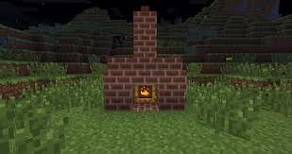 The fireplace.
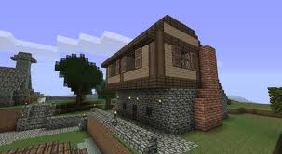 The “spire”.

Here is a strange picture….

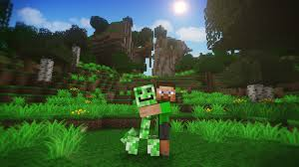 Some happy creeper. Here is another strange photo…
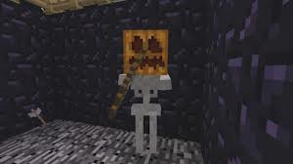 Pumpkinhead.
And now we end this book. See you in minecraft!
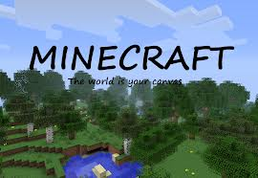 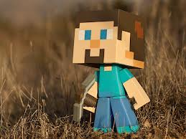 Wa-hoo!
The sequel: craft. See you there!

